
ALI RAZA
9864
BSCS
DSA-A

Revision lab no 02

Task no 01:

Task 1: Abstract Classes
Scenario: A company wants a system to handle different types of employees. Each employee type has a different way of calculating their monthly salary.
What you will do in this task:
- Define an abstract class Employee with a pure virtual function calculateSalary(). (5)
- Create two derived classes, e.g., FullTimeEmployee and PartTimeEmployee, that implement the calculateSalary() function. (7)
- Demonstrate polymorphism using base class pointers or references to call calculateSalary() for different employee types. (5)
- Ensure proper compilation and display the salary output for both types of employees. (3)

Program:
#include <iostream>
using namespace std;

class Employee {
public:
virtual double calculateSalary() = 0;
};
class FullTimeEmployee : public Employee {
private:
double monthlySalary;
public:
FullTimeEmployee(double salary) : monthlySalary(salary) {}
double calculateSalary() override {
return monthlySalary;
}
};

class PartTimeEmployee : public Employee {
private:
double hourlyRate;
int hoursWorked;
public:
PartTimeEmployee(double rate, int hours) : hourlyRate(rate), hoursWorked(hours) {}
double calculateSalary() override {
return hourlyRate * hoursWorked;
}
};

int main() {
Employee* emp1 = new FullTimeEmployee(50000);
Employee* emp2 = new PartTimeEmployee(500, 80);
cout << "Full-Tme Employee Salary: " << emp1->calculateSalary() << endl;
cout << "Part-Time Employe Salary: " << emp2->calculateSalary() << endl;

delete emp1;
delete emp2;

return 0;
}

Output:
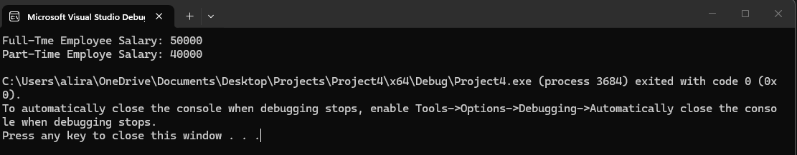
Task no 02:
Scenario: A company wants a generic storage system that can store different types of data like integers, floats, or strings and perform basic operations.
What you will do in this task:
- Create a template class Storage that supports generic data types. (6)
- Implement basic operations: insert(), delete(), and display(). (7)
- Instantiate the template with at least two different data types, e.g., int and string. (5)
- Ensure correct output and maintain proper code structure. (2)
Program:
#include <iostream>
#include <vector>
using namespace std;

template <class T>
class Storage {
vector<T> items;
public:
void insert(T value) {
items.push_back(value);
}

void remove(T value) {
for (int i = 0; i < items.size(); i++) {
if (items[i] == value) {
items.erase(items.begin() + i);
break;
}
}
}
void display() {
for (T val : items) {
cout << val << " ";
}
cout << endl;
}
};

int main() {

Storage<int> intStore;
intStore.insert(1);
intStore.insert(2);
intStore.insert(3);
intStore.display();
intStore.remove(2);
intStore.display();

Storage<string> strStore;
strStore.insert("syed");
strStore.insert("Ali");
strStore.insert("Raza");
strStore.display();
strStore.remove("Raza");
strStore.display();

return 0;
}
Output:
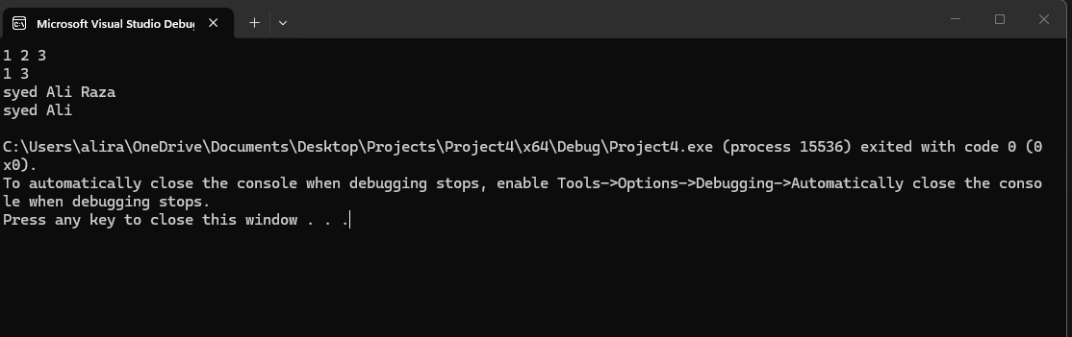
TASK NO 03:
Scenario: A company needs a system to manage product inventory, where they can add, remove, search, and update products stored in an array or vector.
What you will do in this task:
- Declare and initialize an array or vector to store product information. (5)
- Perform access and update operations on the array/vector. (5)
- Implement searching functionality to find a specific product. (5)
- Implement insertion and deletion of products in the array/vector. (7)
- Display results clearly to show the current inventory. (3)
Program:
#include <iostream>
#include <vector>
using namespace std;

int main() {
vector<string> products = { "Laptop", "Mouse", "Keyboard" };
cout << "Initial Inventory:";
for (string product : products) {
cout << product << endl;
}
cout << "First product: " << products[0] << endl;
products[1] = "Wireless Mouse";
string searchItem = "Keyboard";
bool found = false;

for (int i = 0; i < products.size(); i++) {
if (products[i] == searchItem) {
cout << "Product found: " << products[i]
<< " at index " << i << endl;
found = true;
break;
}
}
if (!found) {
cout << "Product not found";
}

products.push_back("Monitor");
products.erase(products.begin());
cout << "Final Inventory:";
for (string product : products) {
cout << product << endl;
}

return 0;
}
Output:
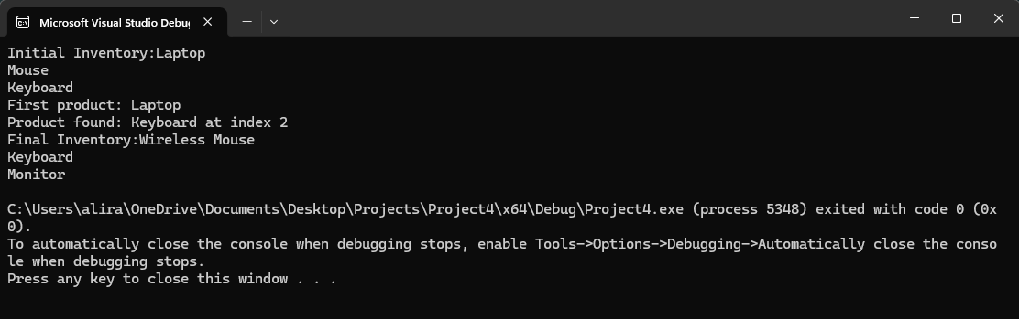
Task no 04:
Scenario: A company wants to understand the efficiency of different operations in their system by analyzing time complexity.
What you will do in this task:
- Write a program demonstrating O(1) complexity, e.g., accessing an element in an array. (5)
- Write a program demonstrating O(n) complexity, e.g., linear search in an array. (5)
- Write a program demonstrating O(n²) complexity, e.g., bubble sort or nested loops. (5)
- Clearly analyze and mention the time complexity in the code comments. (5)
Program:
#include <iostream>
using namespace std;

int main() {

int arr[5] = { 10, 20, 30, 40, 50 };

cout << arr[2] << endl;

int search = 40;
for (int i = 0; i < 5; i++) {
if (arr[i] == search) {
cout << "Found" << endl;
break;
}
}

for (int i = 0; i < 5; i++) {
for (int j = i + 1; j < 5; j++) {
if (arr[i] > arr[j]) {
int temp = arr[i];
arr[i] = arr[j];
arr[j] = temp;
}
}
}

for (int i = 0; i < 5; i++) {
cout << arr[i] << " ";
}

return 0;
}
Output:
